Student Performance Prediction System

Project Id: AIML-5

Name : Member1 (Team Leader)
Class Roll Number:
University Roll Number :
Section and Group:

Name : Member2
Class Roll Number:
University Roll Number :
Section and Group:

- Problem Description 3
- Architecture 4
- Models model 5
- Evaluation metrics used 6
- Preliminary Results and Visualizations 7
- References 8

- Problem Description
The Student Performance Prediction System is a Python-based machine learning application developed to automate the analysis and prediction of student academic outcomes. It streamlines the process of collecting student data, training predictive models, and generating performance insights while maintaining accuracy and efficiency. Using core concepts of Machine Learning such as data preprocessing, feature selection, regression/classification algorithms, model evaluation, and visualization libraries, this project minimizes manual effort in identifying at-risk students and supports data-driven academic decision-making.

- Architecture

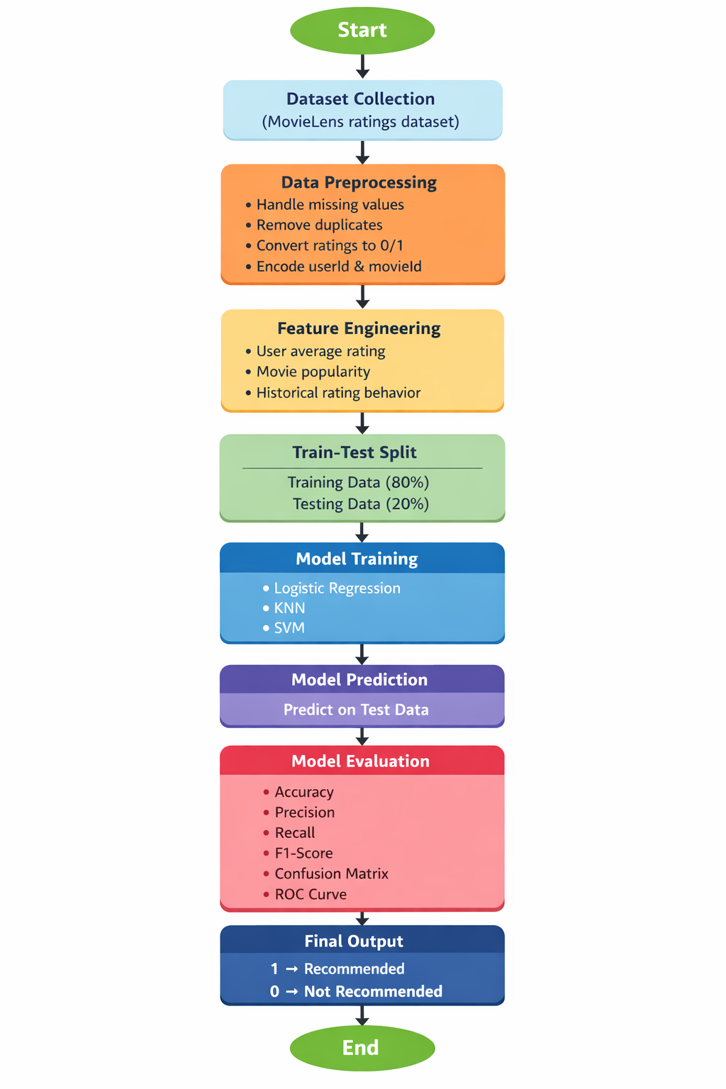
Fig.1 Sample flow diagram.
The architecture of the Urban Water Usage Prediction System follows a structured machine learning pipeline. Raw data is first generated synthetically to simulate realistic conditions including missing values, duplicates, and outliers. The data then passes through a preprocessing stage where duplicates are removed, data types are corrected, invalid values are handled, and missing values are imputed using mean or median strategies. Outliers are detected using both the Z-score (manual) and IQR methods, with IQR used for removal.
After preprocessing, feature scaling is applied using StandardScaler to normalize all input features to a common scale with mean 0 and standard deviation 1. The cleaned and scaled dataset is then split into training and testing sets using an 80-20 ratio. Multiple models are then trained: Linear Regression for predicting exact water usage values, and K-Means Clustering for grouping households with similar consumption patterns. Trained models are saved using joblib for deployment. A separate deployment script loads the saved model and scaler to accept user input and generate real-time predictions without retraining.

- Models Used (Applied / Planned)
3.1 Linear Regression (Applied)
Linear Regression is a supervised learning algorithm used to predict a continuous target variable based on one or more input features. In this project, it was applied to predict the daily water usage (in liters) of a household. The model learns the relationship between input features such as Household Size, Seasonal Index, and Garden Area, and the target variable by fitting a straight line through the data. The model follows the equation y = b0 + b1x1 + b2x2 + b3x3, where y is the predicted water usage and b values are the learned coefficients. The trained model was saved using joblib so that it does not need to be retrained during deployment.
3.2 K-Means Clustering (Applied)
K-Means is an unsupervised learning algorithm that groups data points into K clusters based on their similarity. It does not require labeled output and instead finds hidden patterns in the input data. In this project, K-Means was applied to the advanced dataset using key features such as Household Size, Garden Area, Income Level, and Bathrooms to group households with similar water consumption characteristics. The optimal number of clusters was determined using the Elbow Method. The model was evaluated using Inertia (measuring cluster compactness) and the Silhouette Score (measuring cluster separation). Cluster assignments were visualized using scatter plots.
3.3 KNN Classifier (Planned)
K-Nearest Neighbors (KNN) is a simple and effective supervised learning algorithm that classifies a new data point based on the majority class among its K nearest neighbors in the feature space. For this project, the target variable Daily_Liters_Used will be converted into categories such as Low, Medium, High, and Very High. The KNN Classifier will then be trained to predict which category a household falls into. Since KNN relies on distance calculations, feature scaling using StandardScaler is essential. The model will be evaluated using classification metrics including accuracy, precision, recall, F1 score, and confusion matrix.

- Evaluation metrics used
4.1 Regression Metrics (Linear Regression)
Mean Absolute Error (MAE): Measures the average absolute difference between actual and predicted water usage values. A lower MAE indicates better performance. In this project, the MAE was approximately 49 liters.
Mean Squared Error (MSE): Calculates the average of squared differences between actual and predicted values, penalizing larger errors more heavily. The MSE was approximately 5033 in this project.
Root Mean Squared Error (RMSE): The square root of MSE, bringing the error back to the original unit of liters for easier interpretation. The RMSE was approximately 70 liters.
Mean Absolute Percentage Error (MAPE): Expresses the prediction error as a percentage of actual values. The model achieved a MAPE of approximately 8%, which falls in the excellent accuracy range.
4.2 Clustering Metrics (K-Means)
Inertia: Measures the compactness of clusters by computing the sum of squared distances between data points and their cluster center. A lower inertia value indicates better-defined, tighter clusters.
Silhouette Score: Measures how well-separated the clusters are. Values close to 1 indicate clearly distinct clusters. In this project, the score indicated overlapping clusters, which is expected for continuous real-world data such as water usage.
Elbow Method: A graphical technique used to determine the optimal number of K clusters. Inertia is plotted against K values, and the point where improvement starts to slow forms an elbow shape, indicating the best K.
Z-Score (for Outlier Detection): Used during data preprocessing to detect outliers by measuring how far a value deviates from the mean in standard deviations. Values with absolute Z-score greater than 3 are identified as outliers. This was computed manually without external libraries to demonstrate understanding of the formula.

The following visualizations were generated during the preliminary analysis phase. A correlation heatmap was used to understand the relationship between features. A scatter plot was used to compare actual versus predicted water usage values, and a residual plot was used to analyze prediction errors and verify model assumptions. These visualizations confirm that the Linear Regression model captures the linear relationships in the data with reasonable accuracy.
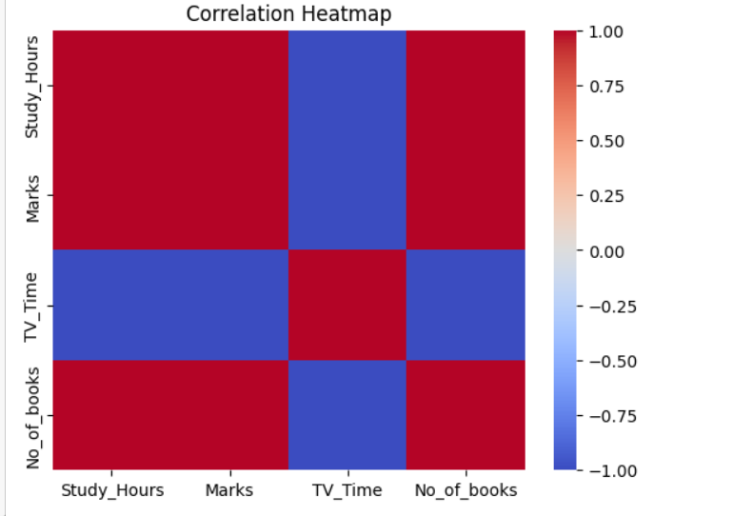

Fig.2 Heatmap showing corelation.

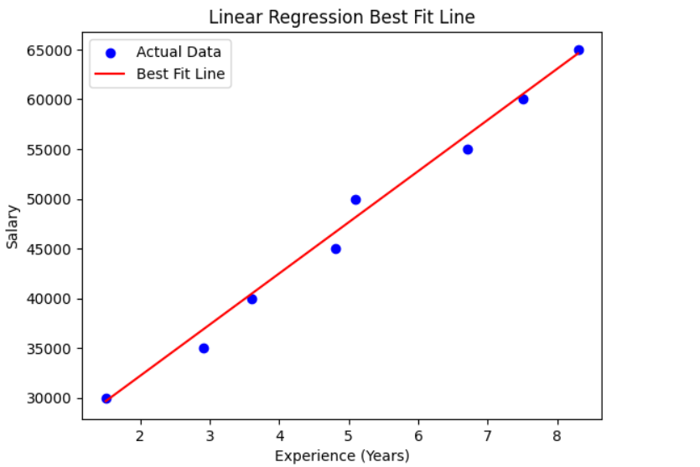
Fig.3 Scatter plot showing Actual vs Predicted Daily Water Usage.

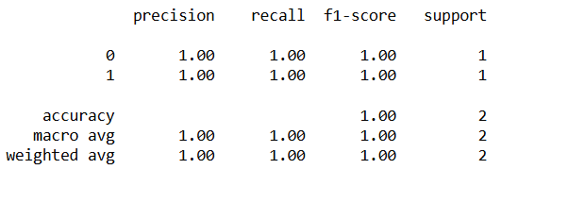

6. References:
Books:
- Let Us Python – Yashavant Kanetkar

Online Resources:
  - GeeksforGeeks – https://www.geeksforgeeks.org/
  - TutorialsPoint – https://www.tutorialspoint.com/cprogramming/index.htm
  - Stack Overflow – https://stackoverflow.com

